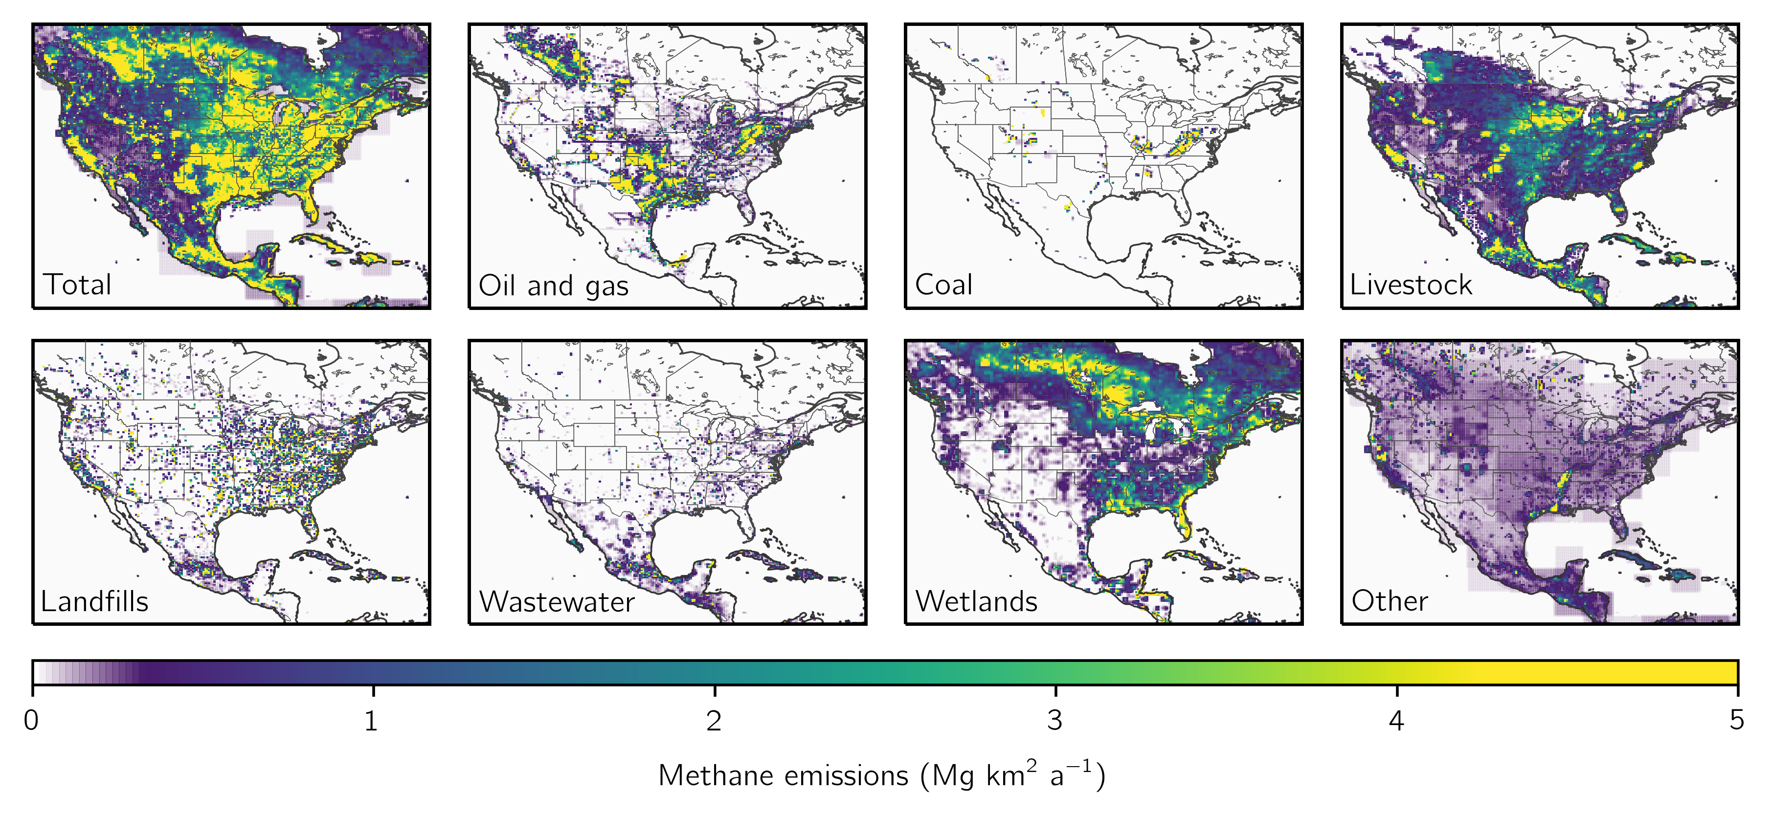

**Figure 1:** Bottom-up methane emission inventories used as prior estimates for the inversion. Panels show annual mean methane emissions for different sectors. Anthropogenic sectors are given by the gridded versions of the national inventories of Canada (ECCC), the U.S. (EPA GHGI), and Mexico (INECC) reported to the UNFCCC (Maasakkers et al., 2016; Scarpelli et al., 2020, 2022). U.S. oil and gas emissions are updated as described in Section 2.2. Wetland emissions are given by the high-performance subset of the WetCHARTs version 1.3.1 wetlands inventory ensemble (Ma et al., 2021), excluding two ensemble members as described in Section 2.2. Emissions are shown on the 0.25° × 0.3125° GEOS-Chem grid used for the inversion.

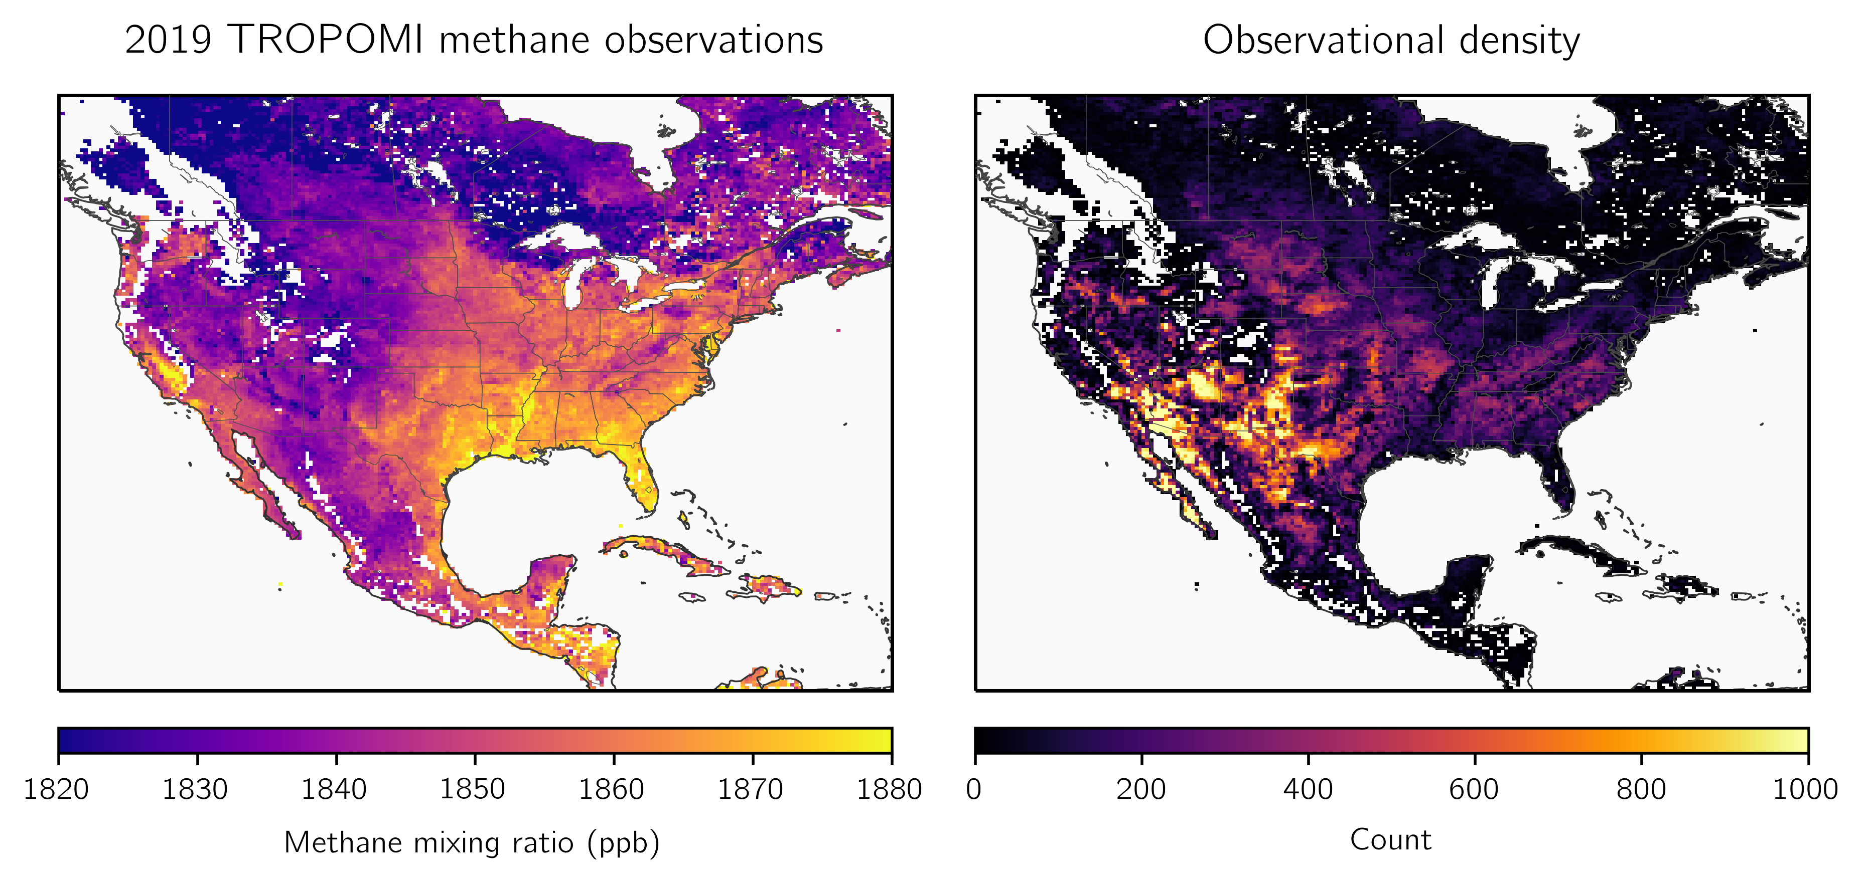

**Figure 2:** TROPOMI methane observations in 2019. The left panel shows the annual average column dry methane mixing ratios for 2019 averaged on the 0.25° × 0.3125° GEOS-Chem grid. The right panel shows the number of observations for the year on the same grid. The observations have been filtered as described in Section 2.4.

**Figure 3:** Optimization of methane emissions for 2019 by inversion of TROPOMI observations. The left panel shows the scale factors relative to the gridded versions of the national anthropogenic emissions inventories for the U.S. (EPA GHGI), Mexico (INECC), and Canada (ECCC) and the WetCHARTs wetland emissions used as prior estimates for the inversion, with updates to U.S. oil and gas emissions as described in Section 2.2 (top left panel of Figure 1). The right panel shows the observing system information content as measured by the averaging kernel sensitivities (the diagonal elements of the averaging kernel matrix). Values of 1 indicate that TROPOMI quantifies emissions independently of the prior estimate, while values of 0 indicate that emissions are not optimized by the inversion. The sum of the averaging kernel sensitivities gives the degrees of freedom for signal (DOFS), shown inset, which defines the number of pieces of information independently quantified by the observing system. Grid cells with averaging kernel sensitivities less than 0.05 are left blank.

**Figure 4:** Sectoral methane emissions in the contiguous United States (CONUS) for 2019. The 2023 EPA GHGI emissions for 2019 (top bars) and posterior estimates given by inversion of TROPOMI data for 2019 (bottom bars) are shown for different sectors. For wetland emissions we show the WetCHARTs estimate (top bar). The shading corresponds to emissions in grid cells that are optimized by the inversion (grid cells with averaging kernel sensitivities greater than 0.05), while the white represents emissions not optimized by the inversion so that the posterior defaults to the prior estimate. Error bars on the GHGI emissions represent the GHGI 95% confidence intervals. Error bars on the posterior emissions are given by the spread of the eight-member inversion ensemble. Also shown are independent sectoral emission estimates from previous inversions.

**Figure 5:** Methane emissions for 2019 from 73 individual landfills that report methane emissions of 2.5 Gg a-1 or more to the EPA’s Greenhouse Gas Reporting Program (GHGRP) for 2019 and for which our TROPOMI inversion provides site-specific information. The left panel shows the location of the landfills, with insets for parts of California (left) and Illinois and Indiana (right). Posterior emissions for each landfill are shown by the size of the marker. The colors show differences (Δ) between the posterior and GHGRP emissions for 2019, with red colors indicating posterior emissions larger than the reported value. Facilities that collect landfill gas are shown as circles, and others are shown as diamonds. The numbers (1 to 10) identify the top 10 methane-producing landfills listed in Table 3, and the letters (a to i) identify the nine validation sites listed in the right panel and outlined in gold. Validation sites are landfills with independent estimates from aircraft campaigns as listed in the legend. Cambaliza et al. (2015) based their estimates on data from 2011, CARB (2020) on data from 2019 to 2021, Duren et al. (2019) on data from 2016 to 2018, and Catena et al. (2022) on data from November 2021. The right panel shows GHGRP (top bars) and posterior (bottom bars) emissions for the validation sites, along with values reported from the aircraft campaigns. Sites are (a) South Side Landfill, (b) West Miramar Sanitary Landfill, (c) Seneca Meadows Landfill, (d) Kiefer Landfill, (e) Puente Hills Landfill, (f) Frank R. Bowerman Landfill, (g) Altamont Landfill, (h) Newby Island Landfill, and (i) Keller Canyon Landfill.

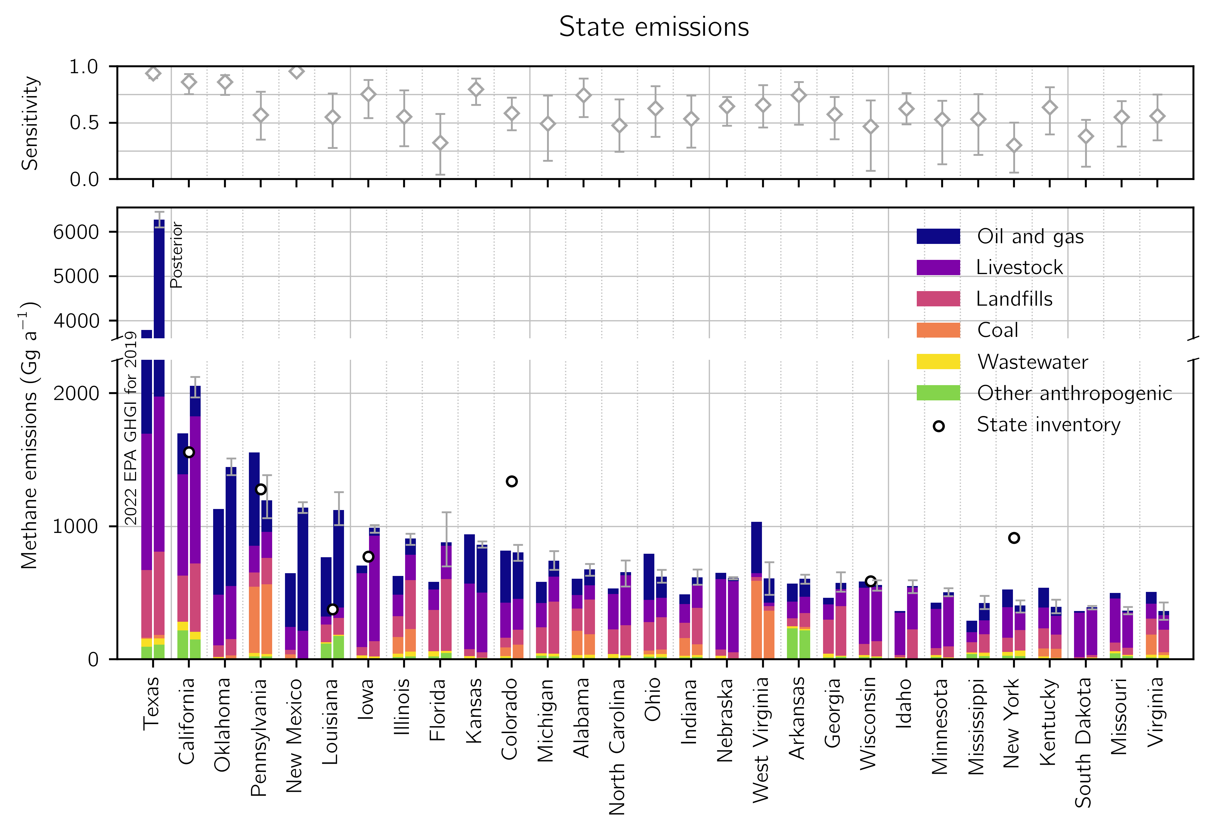

**Figure 6:** Anthropogenic methane emissions in 2019 for the 29 states responsible for 90% of U.S. anthropogenic posterior emissions. The bottom panel shows 2022 EPA GHGI state estimates for 2019 (left bar) and our posterior estimates from the inversion of TROPOMI data (right bar) divided by sector. States are listed from largest to smallest posterior emissions. The information content from the TROPOMI data as defined by the reduced-form averaging kernel sensitivities (the diagonal elements of the reduced-form averaging kernel matrix; Section 2.8) is shown in the top panel. Values of 1 indicate full sensitivity to TROPOMI, while values of 0 indicate no sensitivity. The error bars give the spread from the eight-member inversion ensemble. Also shown are emissions estimates from independent state inventories referenced by EPA (2022).

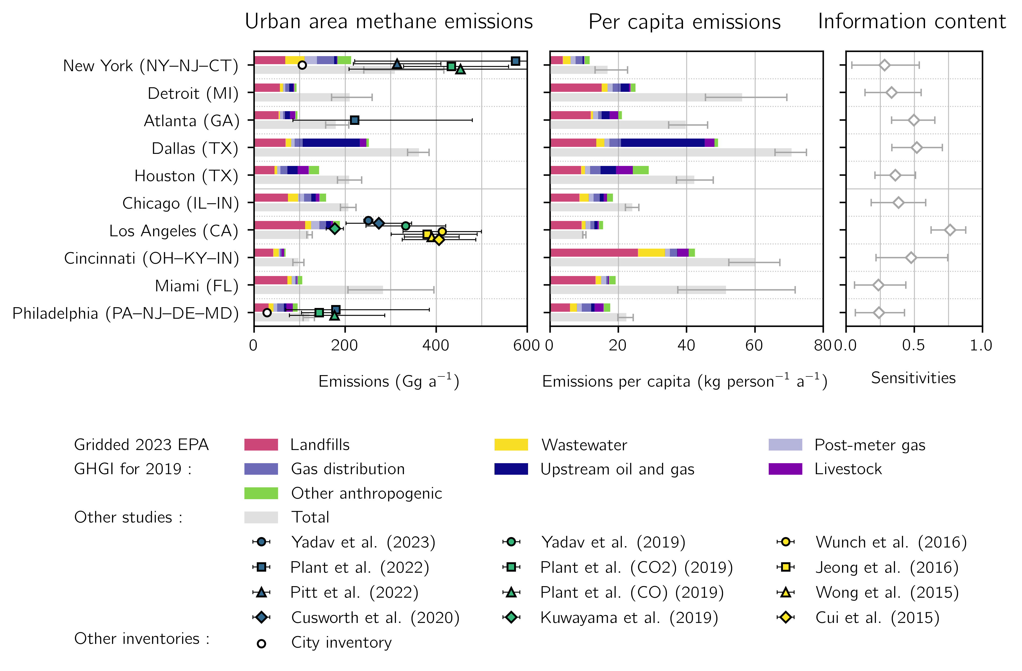

**Figure 7:** Anthropogenic methane emissions for the largest 10 methane-producing urban areas in the contiguous United States (CONUS) for 2019 as identified by the inversion of TROPOMI data. Urban area extents are given by the U.S. Census Bureau TIGER/Line files (U.S. Census, 2010). The top bars show prior anthropogenic sectoral emissions from the 2022 EPA GHGI for 2019 spatially allocated following Maasakkers et al. (2016) with post-meter emissions allocated by population. The bottom bar shows posterior emissions from the TROPOMI inversion for 2019. We do not resolve posterior sectoral emissions estimates due to source colocation within urban areas at the scale of the inversion. Total emissions (left panel), per capita emissions (center panel), and averaging kernel sensitivities (right panel) are shown for each urban area. Error bars represent the spread of the eight-member inversion ensemble. Also shown are independent urban emissions estimates.

**Table 1:** The eight members of the inversion ensemble.

|  |  |  |  |
| --- | --- | --- | --- |
| **Optimized boundary conditions**1 | **Latitude correction**2 | **Prior error standard deviation**3 | **Regularization factor**3 |
| Yes | Yes | 50% | 0.2 |
| 75% | 0.45 |
| Yes | No | 50% | 0.175 |
| 75% | 0.3 |
| 100% | 0.5 |
| No | Yes | 50% | 0.175 |
| 75% | 0.35 |
| No | No | 75% | 0.175 |

We conduct inversions that either do or do not optimize the boundary conditions. In inversions with optimized boundary conditions, we include in the inversion state vector four boundary condition elements corresponding to the northern, eastern, southern, and western borders of the North American domain.

2 We also conduct inversions that either do or do not correct the latitudinal bias in the prior (model – observation) difference with a first order polynomial. In inversions without a latitudinal correction, we remove the mean prior (model – observation) difference as driven by boundary condition biases.

3 We balance the prior and observing system errors to avoid overfitting the emissions to the observations. The regularization factor $γ$ is applied to the inverse observing system error covariance matrix $S_{O}^{-1}$ so that values less than one increase the observing system errors. We choose the value of the regularization factor and the prior error standard deviation for a given inversion so that the prior term of the posterior cost function is approximately one as required by chi-squared statistics (Section 2.7).

**Table 2:** 2019 methane emissions for the contiguous United States (CONUS).

|  |  |  |  |
| --- | --- | --- | --- |
|  | **Inventory emissions**1 | **Posterior emissions**2 | **Sensitivity**3 |
| **Total sources (Tg a-1)** | 35.1 | 39.3 (38.2 - 40.3) |  |
| **Anthropogenic sources** | 27.3 (25.1 - 30.6) | 30.9 (30.0 - 31.8) |  |
| Livestock | 9.4 (8.5 - 10.7) | 10.4 (10.0 - 10.7) | 0.66 (0.55 - 0.76) |
| Oil and natural gas | 9.3 (8.1 - 10.6) | 10.4 (10.1 - 10.7) | 0.91 (0.88 - 0.95) |
| Coal | 2.1 (1.9 - 2.5) | 1.5 (1.2 - 1.9) | 0.60 (0.45 - 0.80) |
| Landfills | 4.6 (3.7 - 5.8) | 6.9 (6.4 - 7.5) | 0.47 (0.34 - 0.64) |
| Wastewater | 0.8 (0.5 - 1.0) | 0.6 (0.5 - 0.7) | 0.33 (0.16 - 0.60) |
| Other anthropogenic | 1.2 (0.7 - 1.8) | 1.1 (1.0 - 1.2) | 0.59 (0.44 - 0.76) |
| **Natural sources** | 7.8 | 8.4 (8.1 - 8.6) |  |
| Wetlands | 6.6 | 7.2 (7.0 - 7.4) | 0.35 (0.16 - 0.55) |
| Other biogenic | 1.1 | 1.2 (1.2 - 1.2) | 0.25 (0.19 - 0.32) |

1Inventory estimates of sectoral methane emissions. Anthropogenic emissions are given by the EPA 2023 GHGI for 2019, with error ranges inferred from the sum in quadrature of bottom-up subsector errors given as 95% confidence intervals. Wetland emissions are from a subset of the high performance WetCHARTs ensemble version 1.3.1; see Section 2.2 for details.

2Optimized emissions from the inversion of TROPOMI data, with the range from the eight members of the inversion ensemble shown in parentheses.

3The sensitivity of the posterior emissions to the observing system as given by the diagonal elements of the sectoral averaging kernel matrix calculated as described in Section 2.8. The values in parentheses give the range of the inversion ensemble. Values range from 0 (no sensitivity) to 1 (full sensitivity).

**Table 3:** Top 10 methane-producing landfills in CONUS for 2019.

|  |  |  |  |  |  |
| --- | --- | --- | --- | --- | --- |
| **Facility**1 | **Location** | **Emissions (Gg a-1)** | | **Gas capture efficiency** | |
| **GHGRP**2 | **Posterior**3 | **GHGRP**4 | **Posterior**5 |
| 1. National Serv-All Landfill | Fort Wayne, Indiana | 3.4 | 44 (34 - 59) | 0.86 | 0.32 (0.26 - 0.37) |
| 2. South Shelby Landfill | Memphis, Tennessee | 4.1 | 41 (30 - 56) | 0.86 | 0.39 (0.31 - 0.46) |
| 3. South Side Landfill Inc. | Indianapolis, Indiana | 4.7 | 39 (32 - 52) | N/A | N/A |
| 4. Rumpke Sanitary Landfill | Cincinnati, Ohio | 10.1 | 39 (33 - 43) | 0.84 | 0.58 (0.55 - 0.61) |
| 5. Quad Cities Landfill Phase IV | Milan, Illinois | 3.7 | 35 (28 - 47) | N/A | N/A |
| 6. City of Dothan Sanitary Landfill | Dothan, Alabama | 5.8 | 35 (28 - 43) | N/A | N/A |
| 7. Rochelle Municipal Landfill | Rochelle, Illinois | 2.7 | 32 (25 - 39) | 0.76 | 0.22 (0.18 - 0.26) |
| 8. Seminole Road MSW Landfill | Ellenwood, Georgia | 12.3 | 30 (25 - 36) | 0.18 | 0.08 (0.07 - 0.1) |
| 9. Caterpillar Inc.-Mapleton | Mapleton, Illinois | 6.4 | 25 (23 - 29) | N/A | N/A |
| 10. Sampson County Disposal, LLC | Roseboro, North Carolina | 29.2 | 25 (23 - 29) | 0.37 | 0.41 (0.38 - 0.44) |

1The top 10 landfills with the largest posterior methane emissions from the TROPOMI inversion for 2019. Numbers correspond to the labels in Figure 5.

2Emissions reported by individual landfills to the EPA GHGRP for 2019 in gigagrams per year.

3Posterior emissions from inversion of TROPOMI observations in gigagrams per year. Posterior emissions are allocated to individual facilities as described in Sections 2.8 and 3.2. Values in parentheses represent the range from the eight-member inversion ensemble.

4For facilities that capture landfill gas, the recovery efficiency as calculated from emissions and avoided emissions reported by individual landfills to the EPA LMOP. Facilities that do not capture landfill gas are listed as N/A.

5The posterior recovery efficiency as calculated from posterior emissions and the avoided emissions reported by individual landfills to the EPA LMOP.

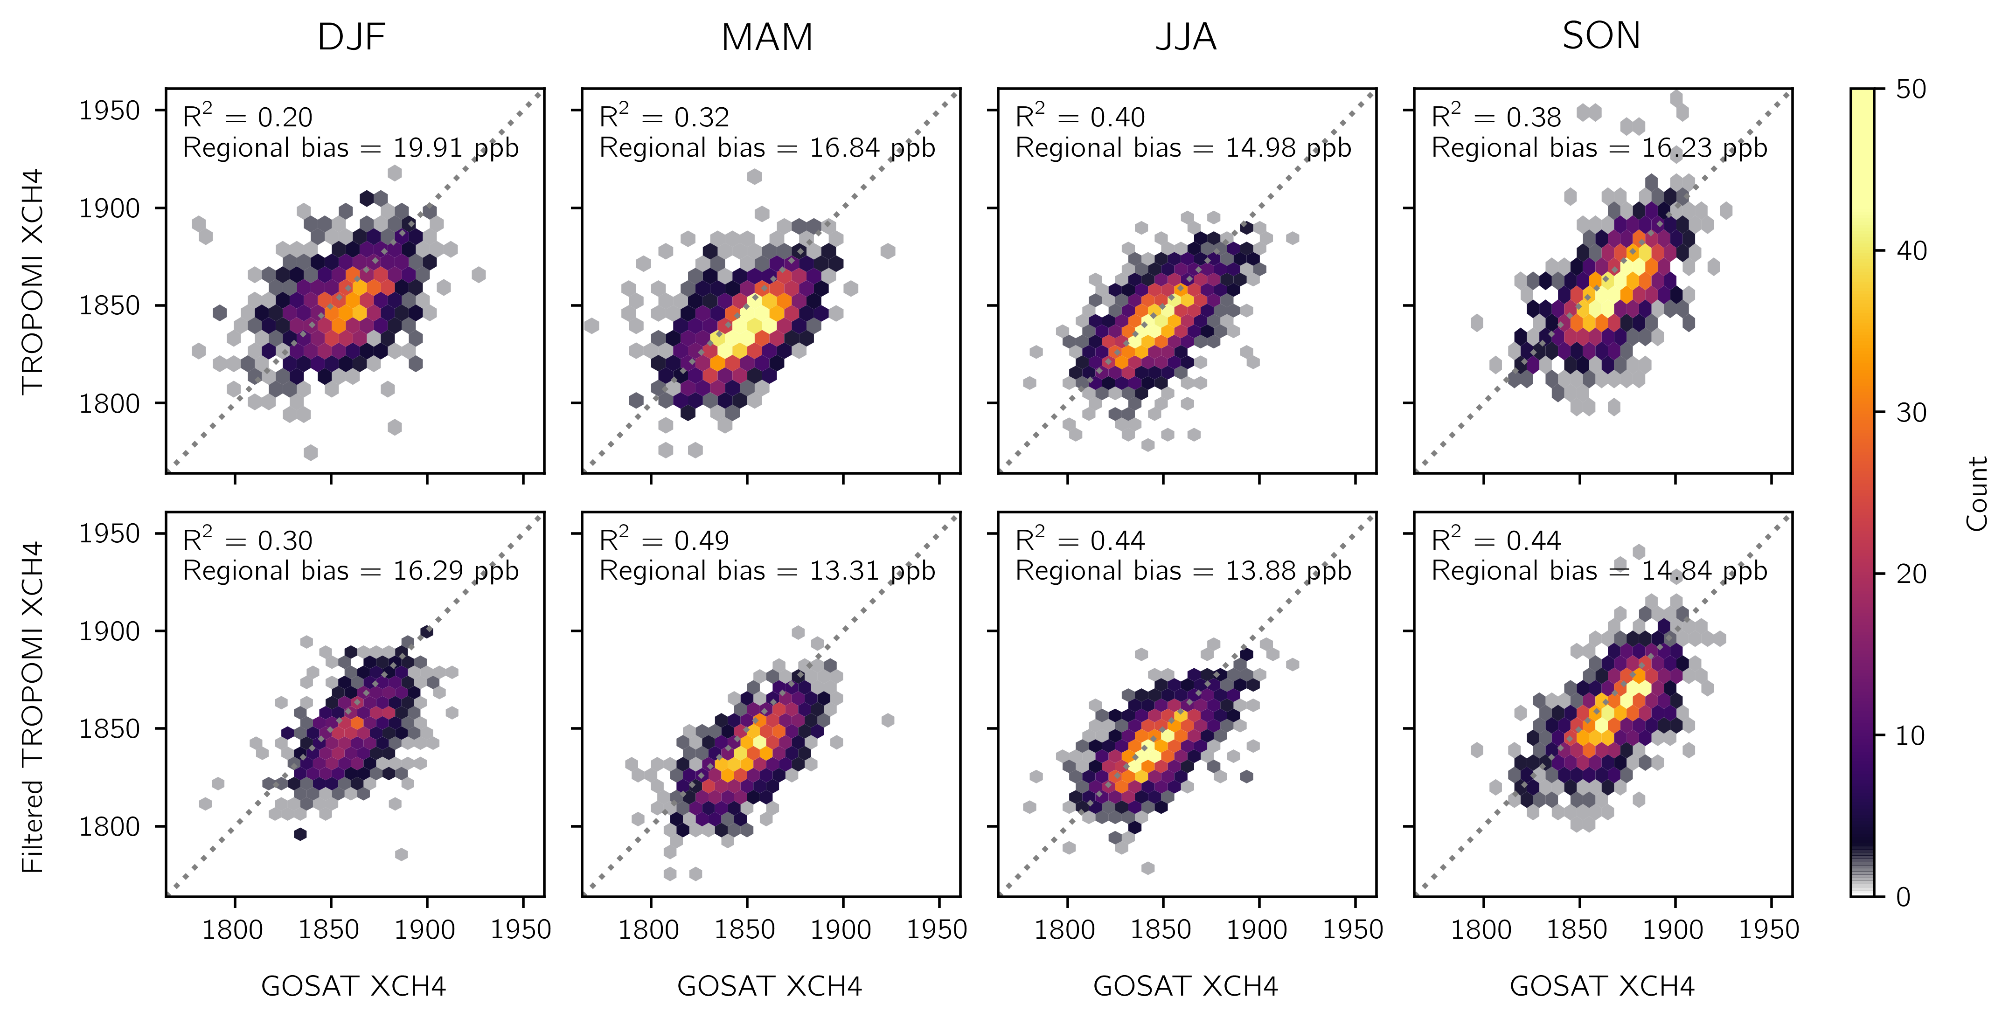**Figure S1:** Evaluation of the TROPOMI methane data with GOSAT observations. Each panel shows the TROPOMI data (y-axis) plotted against the GOSAT observations (x-axis), each averaged on a 2° × 2° grid over the North America domain (Figure 2). Data density is shown instead of individual points. Columns show data for each season. The top row shows the unfiltered TROPOMI data with only the standard quality assessment filter applied. The bottom row shows the filtered TROPOMI data that removes observations over scenes that are likely snow- and ice-covered following Section 2.4. Inset are the squared Pearson correlation coefficient (R2) and the regional bias defined as the standard deviation of the grid-cell-to-grid-cell bias.

**Figure S2:** Quantification of (GEOS-Chem - TROPOMI) biases in a simulation run with the prior emissions. The bold line shows the annual mean (GEOS-Chem - TROPOMI) difference by latitude, with error bars given by the one standard deviation range. Light lines show the (GEOS-Chem - TROPOMI) difference averaged seasonally. Grey lines give the mean bias ($ξ=$ 9.11 ppb) and the latitudinal bias fit ($ξ=-5.40 + 0.39θ$, where $θ$ is the degrees latitude) used as corrections to the (model - observation) difference in the eight-member inversion ensemble.

**Figure S3:** Methane emissions from the TROPOMI inversion for the oil and gas sector for individual basins across North America for 2019. Basin boundaries are defined following Shen et al. (2022) and Lu et al. (2023). The posterior emissions are shown as bars, with error bars are given by the eight-member ensemble range. Also shown are basin estimates and error bars from Shen et al. (2022) and Lu et al. (2023) and the 0.5 Tg a-1 threshold for successful emission quantification from Shen et al. (2022).

**Table S1:** Methane emissions from the 48 states in the contiguous United States for 2019.

|  |  |  |  |  |  |  |  |  |  |  |  |  |  |  |  |
| --- | --- | --- | --- | --- | --- | --- | --- | --- | --- | --- | --- | --- | --- | --- | --- |
| **Emissions (Gg a-1)**1 | **Livestock** | | **Oil and gas** | | **Coal** | | **Landfills** | | **Wastewater** | | **Other anthropogenic** | | **Total** | | |
| **State** | **GHGI**2 | **x̂**3 | **GHGI** | **x̂** | **GHGI** | **x̂** | **GHGI** | **x̂** | **GHGI** | **x̂** | **GHGI** | **x̂** | **GHGI** | **x̂**4 | **DOFS**5 |
| 1. Texas | 1023 | 1165 | 2096 | 4299 | 9 | 24 | 509 | 627 | 60 | 48 | 94 | 110 | 3790 | 6274 (6101, 6454) | 0.94 (0.89, 0.97) |
| 2. California | 760 | 1104 | 309 | 231 | 0 | 0 | 348 | 514 | 65 | 58 | 217 | 148 | 1698 | 2055 (1970, 2122) | 0.86 (0.75, 0.93) |
| 3. Oklahoma | 380 | 399 | 643 | 894 | 3 | 20 | 86 | 121 | 10 | 3 | 7 | 6 | 1128 | 1444 (1384, 1511) | 0.86 (0.75, 0.92) |
| 4. Pennsylvania | 199 | 196 | 703 | 238 | 498 | 524 | 109 | 196 | 25 | 20 | 22 | 20 | 1555 | 1194 (1061, 1384) | 0.57 (0.35, 0.77) |
| 5. New Mexico | 170 | 211 | 406 | 925 | 28 | 32 | 34 | -34 | 3 | 2 | 6 | 3 | 647 | 1139 (1100, 1180) | 0.96 (0.93, 0.98) |
| 6. Louisiana | 62 | 79 | 443 | 731 | 1 | 2 | 131 | 126 | 10 | 9 | 119 | 174 | 766 | 1121 (1010, 1258) | 0.55 (0.28, 0.76) |
| 7. Iowa | 555 | 793 | 57 | 59 | 0 | 0 | 63 | 116 | 23 | 13 | 6 | 7 | 705 | 989 (952, 1010) | 0.75 (0.54, 0.88) |
| 8. Illinois | 160 | 191 | 143 | 121 | 126 | 170 | 157 | 368 | 25 | 37 | 17 | 21 | 627 | 907 (862, 944) | 0.55 (0.29, 0.79) |
| 9. Florida | 155 | 250 | 56 | 26 | 0 | 0 | 311 | 540 | 38 | 15 | 22 | 47 | 582 | 878 (699, 1106) | 0.32 (0.04, 0.58) |
| 10. Kansas | 490 | 448 | 373 | 358 | 0 | 0 | 54 | 41 | 18 | 9 | 5 | 3 | 940 | 860 (839, 888) | 0.80 (0.66, 0.89) |
| 11. Colorado | 263 | 232 | 392 | 351 | 65 | 102 | 72 | 110 | 14 | 4 | 10 | 5 | 816 | 804 (740, 861) | 0.59 (0.44, 0.72) |
| 12. Michigan | 182 | 187 | 160 | 121 | 0 | 0 | 196 | 392 | 18 | 19 | 27 | 22 | 582 | 742 (674, 813) | 0.49 (0.16, 0.74) |
| 13. Alabama | 102 | 109 | 122 | 120 | 183 | 154 | 168 | 259 | 21 | 25 | 10 | 11 | 605 | 677 (629, 717) | 0.75 (0.55, 0.89) |
| 14. North Carolina | 266 | 375 | 41 | 23 | 0 | 0 | 185 | 225 | 28 | 17 | 12 | 13 | 531 | 654 (547, 744) | 0.48 (0.24, 0.71) |
| 15. Ohio | 165 | 146 | 348 | 160 | 30 | 32 | 214 | 244 | 19 | 24 | 18 | 16 | 793 | 622 (578, 673) | 0.63 (0.38, 0.82) |
| 16. Indiana | 140 | 170 | 74 | 60 | 132 | 79 | 115 | 274 | 15 | 17 | 13 | 16 | 489 | 616 (561, 676) | 0.54 (0.28, 0.74) |
| 17. Nebraska | 531 | 533 | 45 | 24 | 0 | 0 | 47 | 46 | 22 | 5 | 4 | 3 | 649 | 611 (604, 619) | 0.64 (0.48, 0.73) |
| 18. West Virginia | 28 | 26 | 386 | 182 | 582 | 360 | 30 | 32 | 3 | 2 | 5 | 4 | 1033 | 607 (485, 730) | 0.66 (0.46, 0.83) |
| 19. Arkansas | 124 | 122 | 136 | 134 | 0 | 13 | 61 | 106 | 15 | 10 | 233 | 218 | 568 | 605 (569, 636) | 0.74 (0.48, 0.86) |
| 20. Georgia | 114 | 127 | 51 | 47 | 0 | 0 | 256 | 374 | 28 | 9 | 14 | 18 | 462 | 575 (509, 655) | 0.58 (0.35, 0.73) |
| 21. Wisconsin | 424 | 407 | 46 | 16 | 0 | 0 | 83 | 114 | 15 | 8 | 17 | 14 | 584 | 559 (518, 595) | 0.47 (0.07, 0.70) |
| 22. Idaho | 316 | 317 | 13 | 11 | 0 | 0 | 20 | 219 | 5 | 2 | 8 | 3 | 362 | 551 (498, 596) | 0.63 (0.49, 0.76) |
| 23. Minnesota | 295 | 381 | 48 | 26 | 0 | 0 | 52 | 83 | 16 | 4 | 15 | 10 | 426 | 504 (475, 534) | 0.53 (0.13, 0.69) |
| 24. Mississippi | 77 | 104 | 87 | 132 | 3 | 6 | 73 | 134 | 11 | 24 | 40 | 23 | 291 | 423 (380, 478) | 0.53 (0.22, 0.75) |
| 25. New York | 230 | 139 | 131 | 47 | 0 | 0 | 107 | 154 | 29 | 43 | 27 | 23 | 524 | 405 (352, 445) | 0.30 (0.06, 0.50) |

|  |  |  |  |  |  |  |  |  |  |  |  |  |  |  |  |
| --- | --- | --- | --- | --- | --- | --- | --- | --- | --- | --- | --- | --- | --- | --- | --- |
| **Emissions (Gg a-1)**1 | **Livestock** | | **Oil and gas** | | **Coal** | | **Landfills** | | **Wastewater** | | **Other anthropogenic** | | **Total** | | |
| **State** | **GHGI**2 | **x̂**3 | **GHGI** | **x̂** | **GHGI** | **x̂** | **GHGI** | **x̂** | **GHGI** | **x̂** | **GHGI** | **x̂** | **GHGI** | **x̂**4 | **DOFS**5 |
| 26. Kentucky | 154 | 143 | 148 | 68 | 61 | 69 | 152 | 105 | 11 | 4 | 9 | 7 | 536 | 395 (347, 449) | 0.64 (0.40, 0.82) |
| 27. South Dakota | 332 | 347 | 13 | 12 | 0 | 0 | 11 | 18 | 5 | 12 | 2 | 2 | 362 | 392 (376, 401) | 0.38 (0.11, 0.53) |
| 28. Missouri | 331 | 266 | 42 | 14 | 0 | 0 | 64 | 54 | 16 | 9 | 44 | 24 | 497 | 367 (339, 394) | 0.55 (0.29, 0.69) |
| 29. Virginia | 112 | 109 | 88 | 31 | 153 | 20 | 119 | 169 | 20 | 22 | 14 | 11 | 507 | 362 (299, 428) | 0.56 (0.35, 0.75) |
| 30. Tennessee | 132 | 122 | 54 | 40 | 2 | 2 | 114 | 132 | 13 | 20 | 9 | 7 | 324 | 322 (301, 349) | 0.60 (0.33, 0.77) |
| 31. Montana | 215 | 211 | 87 | 63 | 20 | 10 | 13 | 19 | 2 | 1 | 8 | 3 | 344 | 306 (292, 322) | 0.31 (0.22, 0.40) |
| 32. North Dakota | 136 | 124 | 139 | 141 | 5 | 6 | 18 | 26 | 2 | 2 | 3 | 2 | 302 | 300 (286, 317) | 0.59 (0.41, 0.70) |
| 33. Washington | 147 | 149 | 25 | 20 | 0 | 0 | 70 | 98 | 16 | 14 | 21 | 13 | 280 | 293 (269, 337) | 0.10 (0.04, 0.14) |
| 34. Utah | 92 | 105 | 103 | 49 | 28 | 79 | 30 | 49 | 6 | 0 | 5 | 3 | 265 | 285 (248, 336) | 0.74 (0.57, 0.87) |
| 35. Oregon | 115 | 132 | 24 | 23 | 0 | 0 | 55 | 111 | 7 | 3 | 14 | 8 | 215 | 276 (256, 304) | 0.08 (0.05, 0.11) |
| 36. Arizona | 121 | 141 | 50 | 41 | 1 | 2 | 70 | 72 | 11 | 4 | 6 | 3 | 259 | 263 (261, 266) | 0.80 (0.74, 0.84) |
| 37. South Carolina | 37 | 53 | 26 | 11 | 0 | 0 | 68 | 145 | 12 | 21 | 8 | 8 | 151 | 237 (220, 249) | 0.51 (0.20, 0.70) |
| 38. New Jersey | 4 | 4 | 44 | 51 | 0 | 0 | 56 | 116 | 13 | 35 | 11 | 27 | 128 | 233 (186, 294) | 0.28 (0.06, 0.52) |
| 39. Maryland | 23 | 28 | 19 | 20 | 2 | 4 | 44 | 57 | 12 | 4 | 8 | 7 | 109 | 120 (112, 126) | 0.26 (0.04, 0.45) |
| 40. Nevada | 45 | 49 | 20 | 9 | 0 | 0 | 17 | 30 | 4 | 2 | 3 | 2 | 90 | 93 (93, 93) | 0.00 (0.00, 0.00) |
| 41. Massachusetts | 4 | 4 | 29 | 17 | 0 | 0 | 24 | 48 | 10 | 4 | 9 | 7 | 76 | 80 (66, 93) | 0.15 (0.00, 0.35) |
| 42. Wyoming | 109 | 113 | 281 | 142 | 200 | -186 | 6 | 10 | 1 | 0 | 3 | 1 | 601 | 80 (-194, 279) | 0.68 (0.48, 0.86) |
| 43. Vermont | 38 | 29 | 1 | 0 | 0 | 0 | 6 | 13 | 1 | 1 | 6 | 3 | 52 | 46 (45, 49) | 0.02 (0.00, 0.07) |
| 44. Connecticut | 8 | 5 | 12 | 8 | 0 | 0 | 8 | 15 | 5 | 12 | 5 | 4 | 38 | 45 (35, 51) | 0.26 (0.01, 0.50) |
| 45. Maine | 11 | 10 | 4 | 2 | 0 | 0 | 13 | 20 | 3 | 1 | 10 | 6 | 40 | 38 (37, 39) | 0.00 (0.00, 0.00) |
| 46. New Hampshire | 4 | 5 | 3 | 1 | 0 | 0 | 21 | 16 | 3 | 1 | 6 | 3 | 36 | 25 (23, 27) | 0.03 (0.00, 0.08) |
| 47. Delaware | 3 | 4 | 5 | 2 | 0 | 0 | 17 | 8 | 5 | 5 | 1 | 2 | 31 | 20 (19, 22) | 0.12 (0.04, 0.23) |
| 48. Rhode Island | 0 | 1 | 5 | 4 | 0 | 0 | 6 | 11 | 2 | 2 | 2 | 1 | 15 | 18 (14, 21) | 0.19 (0.07, 0.34) |

Sectoral emissions in gigagrams per year (Gg a-1) for anthropogenic sources.

2Bottom-up emissions for each state from the 2022 EPA GHGI state estimates for 2019.

3Optimized sectoral anthropogenic emissions from an inversion of TROPOMI data for 2019.

4The total anthropogenic optimized emissions. Values in parentheses give the minimum and maximum of the ensemble of 8 inversions.

5The sensitivity of the total state posterior emissions to the observing system, given by the diagonal elements of the state averaging kernel matrix calculated. Values in parentheses give the ensemble range. Sensitivities range from 0 (unresponsive to the observing system) to 1 (fully responsive).

**Table S2:** Methane emissions from urban areas in the contiguous U.S. (CONUS) for 2019.

|  |  |  |  |  |  |  |  |  |  |  |  |  |
| --- | --- | --- | --- | --- | --- | --- | --- | --- | --- | --- | --- | --- |
| **Urban area**1 | | **Spatially allocated GHGI emissions (Gg a-1)**2 | | | | | | | **Posterior emissions** | | | |
| **Landfills** | **Wastewater** | **Post-meter gas** | **Gas distribution** | **Other anthropogenic** | **Total** | | **Total (Gg a-1)**3 | **Sensitivity**4 | | |
| 1. New York--Newark, NY--NJ--CT | | 68.4 | 42.2 | 27.3 | 37.8 | 37.5 | 213.2 | | 309 (241, 417) | 0.28 (0.04, 0.54) | | |
| 2. Detroit, MI | | 56.6 | 6.4 | 5.6 | 8.8 | 16.2 | 93.6 | | 210 (170, 259) | 0.33 (0.14, 0.55) | | |
| 3. Atlanta, GA | | 53.8 | 3.1 | 6.7 | 4.6 | 26.8 | 95 | | 179 (157, 208) | 0.50 (0.33, 0.65) | | |
| 4. Dallas--Fort Worth--Arlington, TX | | 69.3 | 12.3 | 7.6 | 17.4 | 145.1 | 251.7 | | 362 (337, 384) | 0.52 (0.34, 0.70) | | |
| 5. Houston, TX | | 44.9 | 5.7 | 7.4 | 15.3 | 69.6 | 142.9 | | 209 (183, 236) | 0.36 (0.21, 0.51) | | |
| 6. Chicago, IL--IN | | 74.3 | 22.7 | 12.8 | 15.9 | 32.7 | 158.4 | | 207 (190, 224) | 0.38 (0.18, 0.58) | | |
| 7. Los Angeles--Long Beach--Anaheim, CA | | 112.5 | 12.7 | 18.1 | 14.7 | 30.3 | 188.3 | | 121 (116, 127) | 0.76 (0.62, 0.88) | | |
| 8. Cincinnati, OH--KY--IN | | 41.8 | 12.8 | 2.4 | 3.5 | 8.4 | 68.9 | | 98 (85, 109) | 0.48 (0.22, 0.74) | | |
| 9. Miami, FL | | 73.3 | 9.0 | 8.2 | 2.8 | 12.4 | 105.7 | | 284 (206, 395) | 0.24 (0.06, 0.44) | | |
| 10. Philadelphia, PA--NJ--DE--MD | | 31.8 | 10.9 | 8.1 | 14.8 | 30.2 | 95.8 | | 122 (108, 132) | 0.24 (0.07, 0.43) | | |
| 11. Indianapolis, IN | | 22.4 | 1.5 | 2.2 | 3.6 | 16.3 | 46 | | 101 (84, 127) | 0.34 (0.13, 0.60) | | |
| 12. Denver--Aurora, CO | | 42.3 | 2.0 | 3.5 | 5.8 | 29.2 | 82.8 | | 96 (76, 119) | 0.59 (0.43, 0.73) | | |
| 13. Reading, PA | | 11.4 | 0.3 | 0.4 | 1.0 | 16.3 | 29.4 | | 104 (66, 158) | 0.38 (0.15, 0.64) | | |
| 14. Memphis, TN--MS--AR | | 20.1 | 8.1 | 1.6 | 1.4 | 15.9 | 47.1 | | 81 (70, 96) | 0.49 (0.26, 0.71) | | |
| 15. Birmingham, AL | | 31.5 | 5.7 | 1.1 | 2.1 | 83.4 | 123.8 | | 248 (201, 310) | 0.50 (0.28, 0.74) | | |
| 16. Austin, TX | | 23.1 | 1.1 | 2.0 | 4.3 | 10.0 | 40.5 | | 67 (58, 82) | 0.53 (0.32, 0.75) | | |
| 17. Fort Wayne, IN | | 7.9 | 0.5 | 0.5 | 0.8 | 5.3 | 15 | | 58 (45, 74) | 0.31 (0.16, 0.50) | | |
| 18. San Diego, CA | | 21.3 | 2.8 | 4.4 | 3.0 | 5.8 | 37.3 | | 46 (43, 48) | 0.73 (0.56, 0.88) | | |
| 19. Davenport, IA--IL | | 11.9 | 0.5 | 0.4 | 0.7 | 8.6 | 22.1 | | 57 (48, 72) | 0.23 (0.11, 0.37) | | |
| 20. Rockford, IL | | 21.1 | 0.5 | 0.4 | 0.8 | 5.6 | 28.4 | | 49 (34, 54) | 0.33 (0.13, 0.58) | | |
| 21. Corpus Christi, TX | | 16.8 | 0.8 | 0.5 | 1.2 | 22.2 | 41.5 | | 79 (60, 117) | 0.21 (0.10, 0.34) | | |
| 22. Peoria, IL | | 15.0 | 0.5 | 0.4 | 0.6 | 4.4 | 20.9 | | 49 (43, 55) | 0.22 (0.10, 0.33) | | |
| 23. San Francisco--Oakland, CA | | 24.5 | 13.8 | 4.9 | 3.5 | 14.3 | 61 | | 69 (59, 87) | 0.30 (0.16, 0.44) | | |
| 24. San Antonio, TX | | 22.2 | 6.2 | 2.6 | 5.4 | 20.2 | 56.6 | | 51 (38, 63) | 0.33 (0.22, 0.44) | | |
| 25. Sacramento, CA | | 25.7 | 2.0 | 2.6 | 2.3 | 30.2 | 62.8 | | 67 (64, 71) | 0.53 (0.33, 0.71) | | |
| 26. Charlotte, NC--SC | | 14.7 | 1.1 | 1.9 | 0.9 | 13.9 | 32.5 | | 50 (42, 59) | 0.39 (0.21, 0.56) | | |
| 27. Minneapolis--St. Paul, MN--WI | | 15.9 | 2.2 | 4.0 | 4.4 | 17.5 | 44 | | 53 (42, 70) | 0.23 (0.07, 0.34) | | |
| 28. Phoenix--Mesa, AZ | | 28.9 | 2.4 | 5.4 | 2.1 | 23.8 | 62.6 | | 43 (40, 47) | 0.79 (0.67, 0.88) | | |
| 29. El Paso, TX--NM | | 7.1 | 2.1 | 1.2 | 1.5 | 5.2 | 17.1 | | 15 (13, 18) | 0.45 (0.33, 0.53) | | |
| **Urban area**1 | **Spatially allocated GHGI emissions (Gg a-1)**2 | | | | | | | **Posterior emissions** | | |
| **Landfills** | | **Wastewater** | **Post-meter gas** | **Gas distribution** | **Other anthropogenic** | **Total** | | **Total (Gg a-1)**3 | **Sensitivity**4 | |
| 30. Oklahoma City, OK | 17.4 | | 0.7 | 1.3 | 3.7 | 19.0 | 42.1 | | 59 (49, 71) | 0.53 (0.30, 0.75) | |
| 31. Riverside--San Bernardino, CA | 14.6 | | 2.5 | 2.9 | 2.2 | 13.1 | 35.3 | | 40 (39, 42) | 0.43 (0.32, 0.54) | |
| 32. Montgomery, AL | 8.6 | | 4.3 | 0.4 | 0.7 | 5.7 | 19.7 | | 32 (27, 37) | 0.20 (0.10, 0.31) | |
| 33. Stockton, CA | 7.3 | | 2.8 | 0.6 | 0.6 | 17.5 | 28.8 | | 57 (47, 68) | 0.25 (0.14, 0.39) | |
| 34. San Jose, CA | 12.2 | | 4.4 | 2.5 | 1.8 | 2.7 | 23.6 | | 26 (24, 32) | 0.31 (0.17, 0.47) | |
| 35. Tulsa, OK | 14.3 | | 0.6 | 1.0 | 3.0 | 13.4 | 32.3 | | 36 (28, 43) | 0.39 (0.24, 0.54) | |
| 36. Youngstown, OH--PA | 16.2 | | 0.7 | 0.6 | 1.4 | 25.2 | 44.1 | | 55 (48, 63) | 0.42 (0.21, 0.63) | |
| 37. Grand Rapids, MI | 14.0 | | 0.6 | 0.8 | 2.1 | 18.5 | 36 | | 45 (41, 52) | 0.22 (0.05, 0.33) | |
| 38. Tuscaloosa, AL | 11.8 | | 0.2 | 0.2 | 0.4 | 22.2 | 34.8 | | 55 (45, 69) | 0.50 (0.27, 0.74) | |
| 39. Lancaster, PA | 4.2 | | 0.6 | 0.6 | 1.5 | 22.6 | 29.5 | | 64 (51, 78) | 0.31 (0.15, 0.47) | |
| 40. Pittsburgh, PA | 13.5 | | 3.1 | 2.6 | 6.1 | 282.0 | 307.3 | | 415 (354, 502) | 0.47 (0.23, 0.71) | |
| 41. Lexington-Fayette, KY | 9.3 | | 0.3 | 0.4 | 0.4 | 6.8 | 17.2 | | 27 (22, 33) | 0.37 (0.21, 0.54) | |
| 42. Sioux Falls, SD | 2.2 | | 5.5 | 0.2 | 0.3 | 6.8 | 15 | | 32 (28, 39) | 0.33 (0.22, 0.48) | |
| 43. Fairfield, CA | 10.0 | | 0.7 | 0.2 | 0.3 | 3.8 | 15 | | 23 (21, 24) | 0.24 (0.11, 0.38) | |
| 44. St. Louis, MO--IL | 18.3 | | 5.6 | 3.2 | 3.0 | 13.7 | 43.8 | | 28 (21, 37) | 0.51 (0.24, 0.73) | |
| 45. McKinney, TX | 5.6 | | 0.3 | 0.3 | 0.6 | 2.1 | 8.9 | | 21 (16, 32) | 0.42 (0.21, 0.65) | |
| 46. Chattanooga, TN--GA | 13.8 | | 0.7 | 0.6 | 0.6 | 6.1 | 21.8 | | 22 (13, 31) | 0.33 (0.21, 0.45) | |
| 47. Washington, DC--VA--MD | 12.4 | | 6.6 | 6.8 | 7.4 | 16.3 | 49.5 | | 29 (15, 39) | 0.24 (0.06, 0.39) | |
| 48. Lansing, MI | 11.0 | | 0.3 | 0.5 | 0.9 | 6.2 | 18.9 | | 22 (12, 28) | 0.33 (0.13, 0.58) | |
| 49. Mauldin--Simpsonville, SC | 4.2 | | 1.0 | 0.2 | 0.1 | 0.7 | 6.2 | | 17 (12, 28) | 0.30 (0.17, 0.45) | |
| 50. Greensboro, NC | 12.7 | | 0.4 | 0.5 | 0.3 | 5.5 | 19.4 | | 19 (15, 23) | 0.44 (0.30, 0.58) | |
| 51. Appleton, WI | 9.0 | | 0.3 | 0.3 | 0.4 | 11.7 | 21.7 | | 33 (25, 44) | 0.22 (0.08, 0.43) | |
| 52. York, PA | 5.2 | | 1.1 | 0.3 | 0.9 | 6.2 | 13.7 | | 25 (20, 31) | 0.21 (0.09, 0.37) | |
| 53. Concord, NC | 6.9 | | 0.2 | 0.3 | 0.3 | 5.8 | 13.5 | | 21 (18, 25) | 0.30 (0.18, 0.42) | |
| 54. Kingsport, TN--VA | 17.2 | | 0.5 | 0.2 | 0.2 | 11.1 | 29.2 | | 22 (19, 28) | 0.52 (0.31, 0.72) | |
| 55. Modesto, CA | 3.1 | | 0.6 | 0.5 | 0.6 | 47.5 | 52.3 | | 103 (89, 127) | 0.38 (0.21, 0.58) | |
| 56. Nashville-Davidson, TN | 4.0 | | 6.1 | 1.4 | 1.5 | 17.3 | 30.3 | | 32 (27, 40) | 0.22 (0.11, 0.32) | |
| 57. Fort Collins, CO | 7.6 | | 0.2 | 0.4 | 1.0 | 21.3 | 30.5 | | 35 (33, 39) | 0.20 (0.11, 0.30) | |
| 58. Mission Viejo--Lake Forest--San Clemente, CA | 12.5 | | 3.2 | 0.9 | 0.6 | 2.1 | 19.3 | | 17 (13, 20) | 0.52 (0.39, 0.65) | |

|  |  |  |  |  |  |  |  |  |
| --- | --- | --- | --- | --- | --- | --- | --- | --- |
| **Urban area**1 | **Spatially allocated GHGI emissions (Gg a-1)**2 | | | | | | **Posterior emissions** | |
| **Landfills** | **Wastewater** | **Post-meter gas** | **Gas distribution** | **Other anthropogenic** | **Total** | **Total (Gg a-1)**3 | **Sensitivity**4 |
| 59. Tallahassee, FL | 3.5 | 0.0 | 0.4 | 0.2 | 2.1 | 6.2 | 16 (13, 18) | 0.23 (0.05, 0.44) |
| 60. Laredo, TX | 7.9 | 1.1 | 0.4 | 0.6 | 12.6 | 22.6 | 25 (17, 30) | 0.36 (0.18, 0.58) |
| 61. Wichita, KS | 6.2 | 2.4 | 0.7 | 1.4 | 5.2 | 15.9 | 16 (14, 18) | 0.29 (0.17, 0.42) |
| 62. Canton, OH | 8.8 | 0.4 | 0.4 | 0.8 | 15.3 | 25.7 | 25 (15, 33) | 0.36 (0.15, 0.61) |
| 63. Fort Smith, AR--OK | 4.0 | 0.4 | 0.2 | 0.5 | 14.9 | 20 | 38 (32, 41) | 0.50 (0.27, 0.75) |
| 64. Jacksonville, NC | 4.6 | 0.0 | 0.2 | 0.1 | 5.2 | 10.1 | 15 (13, 17) | 0.24 (0.06, 0.53) |
| 65. Lincoln, NE | 7.3 | 0.2 | 0.4 | 0.7 | 6.5 | 15.1 | 15 (12, 17) | 0.20 (0.10, 0.33) |
| 66. Bakersfield, CA | 3.6 | 0.9 | 0.8 | 0.7 | 30.9 | 36.9 | 78 (71, 90) | 0.61 (0.37, 0.80) |
| 67. Tucson, AZ | 6.6 | 0.3 | 1.3 | 0.6 | 6.7 | 15.5 | 17 (14, 22) | 0.24 (0.16, 0.34) |
| 68. Amarillo, TX | 3.7 | 1.1 | 0.3 | 0.7 | 16.4 | 22.2 | 40 (31, 51) | 0.57 (0.39, 0.74) |
| 69. Antioch, CA | 4.9 | 0.4 | 0.4 | 0.5 | 9.1 | 15.3 | 13 (-1, 22) | 0.24 (0.13, 0.37) |
| 70. Santa Clarita, CA | 7.5 | 0.8 | 0.4 | 0.6 | 3.9 | 13.2 | 10 (7, 12) | 0.27 (0.19, 0.36) |
| 71. El Centro--Calexico, CA | 3.2 | 0.6 | 0.2 | 0.2 | 8.9 | 13.1 | 22 (19, 27) | 0.29 (0.17, 0.44) |
| 72. College Station--Bryan, TX | 3.3 | 0.1 | 0.3 | 0.5 | 15.8 | 20 | 29 (26, 31) | 0.22 (0.12, 0.34) |
| 73. Waco, TX | 4.4 | 0.1 | 0.3 | 0.6 | 3.9 | 9.3 | 11 (8, 14) | 0.20 (0.10, 0.32) |
| 74. McAllen, TX | 7.3 | 1.0 | 1.1 | 2.2 | 21.0 | 32.6 | 38 (32, 46) | 0.33 (0.19, 0.49) |
| 75. Yuba City, CA | 3.4 | 0.1 | 0.2 | 0.2 | 19.1 | 23 | 24 (20, 26) | 0.41 (0.25, 0.58) |
| 76. Denton--Lewisville, TX | 2.2 | 0.2 | 0.5 | 1.2 | 17.1 | 21.2 | 34 (32, 37) | 0.36 (0.21, 0.51) |
| 77. Greeley, CO | 2.4 | 0.0 | 0.2 | 0.5 | 31.4 | 34.5 | 57 (44, 76) | 0.58 (0.36, 0.79) |
| 78. Redding, CA | 3.4 | 0.6 | 0.2 | 0.2 | 1.3 | 5.7 | 7 (6, 8) | 0.53 (0.36, 0.66) |
| 79. Norman, OK | 2.1 | 0.1 | 0.2 | 0.4 | 1.9 | 4.7 | 8 (8, 9) | 0.23 (0.12, 0.37) |
| 80. Victorville--Hesperia, CA | 3.4 | 0.4 | 0.5 | 0.4 | 5.9 | 10.6 | 10 (8, 13) | 0.22 (0.13, 0.31) |
| 81. Visalia, CA | 2.6 | 0.5 | 0.3 | 0.4 | 76.5 | 80.3 | 72 (63, 82) | 0.22 (0.13, 0.33) |
| 82. Gainesville, GA | 3.7 | 0.0 | 0.2 | 0.2 | 4.4 | 8.5 | 8 (3, 11) | 0.21 (0.10, 0.33) |
| 83. Murrieta--Temecula--Menifee, CA | 1.5 | 1.0 | 0.7 | 0.6 | 4.4 | 8.2 | 11 (10, 12) | 0.21 (0.14, 0.29) |
| 84. Monroe, LA | 3.8 | 0.2 | 0.2 | 0.3 | 10.3 | 14.8 | 8 (-4, 14) | 0.22 (0.10, 0.35) |
| 85. Merced, CA | 1.0 | 0.3 | 0.2 | 0.2 | 71.4 | 73.1 | 146 (130, 171) | 0.44 (0.27, 0.63) |
| 86. Abilene, TX | 2.4 | 0.7 | 0.2 | 0.3 | 4.6 | 8.2 | 9 (8, 10) | 0.20 (0.10, 0.34) |
| 87. Charleston, WV | 5.2 | 0.4 | 0.2 | 1.8 | 116.8 | 124.4 | 24 (-3, 52) | 0.52 (0.29, 0.76) |

|  |  |  |  |  |  |  |  |  |
| --- | --- | --- | --- | --- | --- | --- | --- | --- |
| **Urban area**1 | **Spatially allocated GHGI emissions (Gg a-1)**2 | | | | | | **Posterior emissions** | |
| **Landfills** | **Wastewater** | **Post-meter gas** | **Gas distribution** | **Other anthropogenic** | **Total** | **Total (Gg a-1)**3 | **Sensitivity**4 |
| 88. Odessa, TX | 3.7 | 0.3 | 0.2 | 0.4 | 81.9 | 86.5 | 175 (139, 217) | 0.46 (0.36, 0.58) |
| 89. Avondale--Goodyear, AZ | 1.6 | 0.3 | 0.3 | 0.1 | 3.2 | 5.5 | 5 (5, 6) | 0.42 (0.27, 0.57) |
| 90. Midland, TX | 2.4 | 0.2 | 0.2 | 0.5 | 83.5 | 86.8 | 41 (-22, 90) | 0.71 (0.52, 0.86) |
| 91. Las Cruces, NM | 0.7 | 0.3 | 0.2 | 0.2 | 6.3 | 7.7 | 6 (4, 8) | 0.21 (0.13, 0.30) |
| 92. Pueblo, CO | 4.1 | 0.1 | 0.2 | 0.3 | 1.1 | 5.8 | 1 (-3, 3) | 0.26 (0.16, 0.39) |
| 93. Simi Valley, CA | 2.1 | 0.1 | 0.2 | 0.1 | 0.3 | 2.8 | -1 (-4, 0) | 0.27 (0.19, 0.37) |
| 94. Clarksville, TN--KY | 7.0 | 0.6 | 0.2 | 0.2 | 3.7 | 11.7 | 0 (-5, 5) | 0.28 (0.16, 0.43) |
| 95. Kansas City, MO--KS | 34.6 | 3.2 | 2.3 | 3.3 | 17.3 | 60.7 | 3 (-19, 21) | 0.45 (0.22, 0.71) |

Urban areas with populations greater than 1 million that are optimized by the inversion (mean urban averaging kernel sensitivity greater than 0.2), ordered by posterior emissions from landfills, wastewater, and gas distribution. Urban area extents are given by the U.S. Census Topographically Integrated Geographic Encoding and Referencing system (TIGER)/Line Urban Areas.

2The anthropogenic emissions for urban source sectors for each city in gigagrams per year (Gg a-1) from the 2023 EPA GHGI for 2019 allocated using the Gridded EPA inventory (Maasakkers et al., 2016) with post-meter emissions distributed by population. Other emissions include contributions from upstream oil and gas, coal, livestock, and other sources.

3Optimized emissions from inversion of TROPOMI observations in gigagrams per year. Values in parentheses represent the range from an eight-member inversion ensemble.

4The sensitivity of an urban area to the satellite-model observing system as given by the diagonal elements of the urban averaging kernel matrix calculated as described in Section 2.8. Values close to 1 indicate that the posterior emissions are fully sensitive to the observing system, while values close to 0 rely almost entirely on the prior estimate. Values in parentheses give the ensemble range.

**Table S3:** Methane emissions from landfills in the contiguous United States (CONUS) for 2019

|  |  |  |  |  |  |  |  |  |  |
| --- | --- | --- | --- | --- | --- | --- | --- | --- | --- |
| **Facility**1 | **Location** | **Emissions (Gg a-1)** | | | **Gas capture efficiency** | | | | |
| **GHGRP**2 | **Posterior**3 | | **GHGRP**4 | | **Posterior**5 | |
| 1. National Serv-All Landfill | Fort Wayne, Indiana | 3.4 | 44 (34 - 59) | | 0.86 | | 0.32 (0.26 - 0.37) | |
| 2. South Shelby Landfill | Memphis, Tennessee | 4.1 | 41 (30 - 56) | | 0.86 | | 0.39 (0.31 - 0.46) | |
| 3. South Side Landfill Inc. | Indianapolis, Indiana | 4.7 | 39 (32 - 52) | | 0.8 | | 0.33 (0.27 - 0.38) | |
| 4. Rumpke Sanitary Landfill | Cincinnati, Ohio | 10.1 | 39 (33 - 43) | | 0.84 | | 0.58 (0.55 - 0.61) | | |
| 5. Quad Cities Landfill Phase IV | Milan, Illinois | 3.7 | 35 (28 - 47) | | N/A | | N/A | | |
| 6. City of Dothan Sanitary Landfill | Dothan, Alabama | 5.8 | 35 (28 - 43) | | N/A | | N/A | | |
| 7. Rochelle Municipal Landfill | Rochelle, Illinois | 2.7 | 32 (25 - 39) | | 0.76 | | 0.22 (0.18 - 0.26) | | |
| 8. Seminole Road MSW Landfill | Ellenwood, Georgia | 12.3 | 30 (25 - 36) | | 0.18 | | 0.08 (0.07 - 0.1) | | |
| 9. Caterpillar Inc.-Mapleton | Mapleton, Illinois | 6.4 | 25 (23 - 29) | | N/A | | N/A | | |
| 10. Sampson County Disposal, LLC | Roseboro, North Carolina | 29.2 | 25 (23 - 29) | | 0.37 | | 0.41 (0.38 - 0.44) | | |
| 11. West Miramar Sanitary Landfill | San Diego, California | 6.2 | 24 (22 - 25) | | 0.78 | | 0.47 (0.46 - 0.49) | | |
| 12. Seneca Meadows SWMF | Waterloo, New York | 8.3 | 24 (14 - 36) | | 0.88 | | 0.73 (0.63 - 0.81) | | |
| 13. Kiefer Landfill | Sloughhouse, California | 6.5 | 24 (19 - 31) | | 0.81 | | 0.54 (0.46 - 0.58) | | |
| 14. Charlotte Motor Speedway Landfill V | Concord, North Carolina | 6.9 | 23 (18 - 30) | | 0.75 | | 0.48 (0.41 - 0.54) | | |
| 15. Puente Hills Landfill and Energy Recovery | Whittier, California | 2.7 | 22 (19 - 27) | | 0.94 | | 0.67 (0.61 - 0.69) | | |
| 16. Atascocita Recycling and Disposal Facility | Humble, Texas | 11.9 | 21 (16 - 26) | | 0.59 | | 0.45 (0.4 - 0.52) | | |
| 17. Frank R. Bowerman Landfill | Irvine, California | 11.8 | 21 (16 - 32) | | 0.77 | | 0.66 (0.56 - 0.71) | | |
| 18. Kimble Sanitary Landfill | Dover, Ohio | 2.8 | 19 (17 - 24) | | N/A | | N/A | | |
| 19. 121 Regional Disposal Facility | Melissa, Texas | 20.7 | 19 (14 - 29) | | 0.49 | | 0.52 (0.4 - 0.58) | | |
| 20. New Georgia Landfill | Birmingham, Alabama | 5.5 | 19 (17 - 21) | | N/A | | N/A | | |
| 21. Sussex County Landfill | Waverly, Virginia | 7.3 | 17 (12 - 25) | | N/A | | N/A | | |
| 22. Altamont Landfill & Resource Recovery Facility | Livermore, California | 7.3 | 17 (13 - 23) | | 0.74 | | 0.56 (0.48 - 0.63) | | |
| 23. Enoree Landfill | Greer, South Carolina | 3.4 | 17 (11 - 28) | | 0.52 | | 0.19 (0.11 - 0.24) | | |
| 24. Brent Run Landfill | Montrose, Michigan | 18.2 | 17 (14 - 21) | | 0.35 | | 0.37 (0.32 - 0.42) | | |
| 25. Livingston Landfill | Pontiac, Illinois | 4.9 | 17 (14 - 20) | | 0.85 | | 0.62 (0.58 - 0.66) | | |
| 26. Big River Landfill | Leland, Missouri | 6 | 16 (13 - 21) | | N/A | | N/A | | |
| 27. Modern Landfill | York, Pennsylvania | 3.4 | 15 (11 - 22) | | N/A | | N/A | | |
| 28. Newby Island Landfill | Milpitas, California | 5.5 | 15 (13 - 21) | | N/A | | N/A | | |
| 29. Landfill of North Iowa | Clear Lake, Iowa | 2.8 | 14 (11 - 18) | | N/A | | N/A | | |
| 30. Beech Hollow Sanitary Landfill | Wellston, Ohio | 14.5 | 13 (9 - 20) | | N/A | | N/A | | |
| 31. Eastman Chemical Company | Kingsport, Tennessee | 9.3 | 12 (10 - 16) | | N/A | | N/A | | |
| 32. Rumpke of Kentucky Inc. | Jeffersonville, Kentucky | 9.2 | 12 (9 - 15) | | N/A | | N/A | | |
| 33. Jefferson County Landfill No. 1 | Gardendale, Alabama | 8.8 | 11 (10 - 14) | | N/A | | N/A | | |
| 34. Keller Canyon Landfill | Pittsburg, California | 5.6 | 10 (8 - 13) | | 0.55 | | 0.4 (0.35 - 0.47) | | |
| 35. Big Run Landfill | Ashland, Kentucky | 20.9 | 10 (9 - 12) | | N/A | | N/A | | |
| 36. Rockingham County Landfill | Madison, North Carolina | 3.4 | 10 (6 - 13) | | 0.3 | | 0.13 (0.1 - 0.19) | | |
| 37. Granger Grand River Avenue Landfill | Grand Ledge, Michigan | 4.3 | 10 (2 - 14) | | 0.57 | | 0.4 (0.3 - 0.71) | | |
| 38. Leon County Landfill | Tallahassee, Florida | 3.2 | 9 (8 - 11) | | N/A | | N/A | | |
| 39. City of Laredo Landfill | Laredo, Texas | 6.6 | 9 (4 - 12) | | N/A | | N/A | | |
| **Facility**1 | **Location** | **Emissions (Gg a-1)** | | | | **Gas capture efficiency** | | | | |
| **GHGRP**2 | | **Posterior**3 | | **GHGRP**4 | | **Posterior**5 | | |
| 40. Onslow County Landfill | Jacksonville, North Carolina | 3.1 | | 9 (8 - 10) | | 0.53 | | 0.28 (0.25 - 0.3) | | |
| 41. Waste Management Skyline Landfill | Ferris, Texas | 13.8 | | 9 (6 - 12) | | 0.4 | | 0.5 (0.43 - 0.6) | | |
| 42. Matlock Bend Landfill | Loudon, Tennessee | 6.2 | | 8 (6 - 14) | | N/A | | N/A | | |
| 43. Waste Management of OK | Tulsa, Oklahoma | 6.2 | | 8 (6 - 13) | | 0.29 | | 0.24 (0.17 - 0.29) | | |
| 44. City of Chattanooga Summit Landfill | Ooltewah, Tennessee | 3.1 | | 8 (2 - 14) | | N/A | | N/A | | |
| 45. Resolute Forest Products Calhoun Operation | Calhoun, Tennessee | 5.6 | | 8 (5 - 12) | | N/A | | N/A | | |
| 46. La Salle/Grant Parish Sanitary Landfill | Jena, Louisiana | 5.3 | | 7 (5 - 8) | | N/A | | N/A | | |
| 47. Badlands Sanitary Landfill | Moreno Valley, California | 3.2 | | 7 (5 - 8) | | N/A | | N/A | | |
| 48. Bluff Road Landfill | Lincoln, Nebraska | 2.9 | | 7 (5 - 10) | | 0.69 | | 0.5 (0.4 - 0.57) | | |
| 49. Bradley County Landfill | Mcdonald, Tennessee | 10.2 | | 7 (4 - 9) | | N/A | | N/A | | |
| 50. Mccombs Landfill | El Paso, Texas | 11.5 | | 6 (5 - 8) | | N/A | | N/A | | |
| 51. Toro Energy of Ohio - America's Landfill Gas | Waynesburg, Ohio | 2.7 | | 6 (1 - 10) | | 0.78 | | 0.63 (0.47 - 0.9) | | |
| 52. Carbon Limestone Landfill | Lowellville, Ohio | 3.6 | | 6 (3 - 8) | | 0.89 | | 0.83 (0.79 - 0.89) | | |
| 53. City Of Glendale - Landfill | Glendale, Arizona | 5 | | 5 (5 - 6) | | 0.5 | | 0.49 (0.44 - 0.52) | | |
| 54. Lone Cactus Landfill | Phoenix, Arizona | 2.7 | | 5 (4 - 7) | | N/A | | N/A | | |
| 55. Tangerine Landfill | Marana, Arizona | 2.6 | | 5 (3 - 7) | | N/A | | N/A | | |
| 56. Outagamie County Landfill | Appleton, Wisconsin | 2.8 | | 5 (3 - 7) | | 0.75 | | 0.65 (0.55 - 0.72) | | |
| 57. Champ Landfill | Maryland Heights, Missouri | 9.8 | | 4 (1 - 8) | | 0.73 | | 0.86 (0.77 - 0.97) | | |
| 58. Rhea County Landfill | Dayton, Tennessee | 8.3 | | 4 (4 - 5) | | N/A | | N/A | | |
| 59. Noble Road Landfill | Shiloh, Ohio | 16.2 | | 4 (1 - 7) | | N/A | | N/A | | |
| 60. Copper Mountain Landfill | Wellton, Arizona | 4.7 | | 4 (4 - 4) | | N/A | | N/A | | |
| 61. Black Oak Landfill | Hartville, Missouri | 3.8 | | 4 (2 - 6) | | 0.48 | | 0.49 (0.36 - 0.64) | | |
| 62. Brooks Landfill | Wichita, Kansas | 8.3 | | 3 (2 - 4) | | N/A | | N/A | | |
| 63. American Environmental Landfill | Sand Springs, Oklahoma | 7 | | 3 (2 - 4) | | 0.45 | | 0.66 (0.59 - 0.78) | | |
| 64. Prima Deshecha Landfill | San Juan Capistrano, California | 5.1 | | 3 (2 - 4) | | 0.66 | | 0.78 (0.73 - 0.85) | | |
| 65. Meadow Branch Landfill | Athens, Tennessee | 11.2 | | 3 (2 - 3) | | 0.44 | | 0.77 (0.72 - 0.81) | | |
| 66. West Central Landfill | Redding, California | 2.8 | | 3 (2 - 4) | | N/A | | N/A | | |
| 67. Northwestern Landfill | Parkersburg, West Virginia | 3.7 | | 2 (0 - 4) | | N/A | | N/A | | |
| 68. Northwest Regional Landfill | Surprise, Arizona | 4.5 | | 2 (2 - 3) | | 0.51 | | 0.7 (0.61 - 0.74) | | |
| 69. Apex Environmental, LLC - Sanitary Landfill | Amsterdam, Ohio | 19.5 | | 2 (-9 - 8) | | 0.27 | | 0.17 (-4.29 - 1.53) | | |
| 70. Apache Junction Landfill | Apache Junction, Arizona | 2.8 | | 2 (1 - 2) | | N/A | | N/A | | |
| 71. Hall County Candler Road MSWLF | Gainesville, Georgia | 2.9 | | 2 (-2 - 4) | | N/A | | N/A | | |
| 72. Laurel Ridge Landfill | Lily, Kentucky | 10.1 | | 1 (0 - 4) | | 0.3 | | 0.77 (0.52 - 0.96) | | |
| 73. Cactus Landfill | Eloy, Arizona | 3.2 | | 1 (-1 - 1) | | N/A | | N/A | | |

1The 73 landfills that report methane emissions of 2.5 Gg a-1 to the EPA GHGRP and that are located in a grid cell where TROPOMI provides a constraint (averaging kernel sensitivity > 0.2) and where a single landfill explains more than 50% of the prior emissions estimate. Facilities are ranked by the posterior emissions estimate from largest to smallest.

2Emissions reported by individual landfills to the EPA GHGRP for 2019 in gigagrams per year.

3Posterior emissions from inversion of TROPOMI observations in gigagrams per year. Posterior emissions are allocated to individual facilities as described in Sections 2.8 and 3.2. Values in parentheses represent the range from the eight-member inversion ensemble.

4For facilities that capture landfill gas, the recovery efficiency as calculated from emissions and avoided emissions reported by individual landfills to the EPA LMOP. Facilities that do not capture landfill gas are listed as N/A.

5The posterior recovery efficiency as calculated from posterior emissions and the avoided emissions reported by individual landfills to the EPA LMOP.